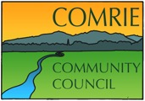

A meeting of the Comrie Community Council will be held by ZOOM video conference on Thursday

8th October 2020 at 7.30 pm

Agenda

Welcome
- Previous Minutes
  - Matters arising
  - Acceptance
- Police Report
- Relevant planning applications
- Road matters
  - Review
  - Actions required
- Treasurer’s Report
- Secretary’s relevant correspondence and updates
- Councilor’s Reports
- AOCB

Date of the next meeting – 12th November 2020.
Likely to be by video conference at 7.00pm – to be confirmed.

