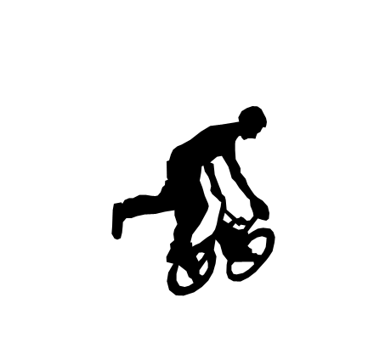
Once in a lifetime chance to buy a block……
Help build a bike and skatepark for Comrie
Comrie Youth Extreme Sports (CYES) are in the final stages of fundraising to build a bike and skate park in Comrie. So far, we have raised £58,000 towards a total build cost of £64,000. We have secured planning permission, land and most of the funding is in place. To help us raise the final amount we are asking local businesses and groups to ‘buy a block ‘!
In return for ‘purchasing’ one of the 10m2 block areas of the park, we will put your name up on a supporters’ plaque for all to see.
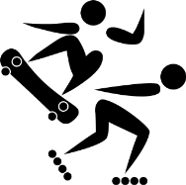
- How much does it cost? One block of 10m2 is £100
- How many blocks are available? There are 60 blocks available
- Can I buy more than one? Yes absolutely!
- What if you want to help but don’t have £100?
Groups of people- including young people - can get together and each put in a smaller amount – so 10 people can give £10 and claim a block or 20 can give £5 each and so on. Just decide on a name for your group and organise one person to gather the money in.
- Can I claim my block?
Sorry – the block needs to stay in place or there will be no place to skate or bike…It is being built in Laggan Park which is held in trust for the village and it will remain there! However feel free to use the bike and skate park…
If you would like to take up this offer please contact Fran Loots/Cammy Carstairs (details below) or speak to one of the other committee members: Sharon Carpenter, Stuart Clark, Chris Palmer, Alison Ritchie, Anita Spurway and return the slip below.
Payment can be by cheque to Comrie Youth Extreme Sports or by bank transfer into our account. We can provide a receipt for cash but would prefer cheque or bank transfer.
Bank Transfer: Comrie Youth Extreme Sports
Cooperative Bank Sort code 089299 and Account Number 65504813

Check out more about our journey www.youtube.com/watch?v=1t4UFj4in48
………………………………………………………………………………………………………………………………………………………
Comrie Youth Extreme Sports Buy a Block
Name of business or group to go on plaque?
How many blocks do you want @ £100 each?
Contact name email: tel:
Payment method : please circle Cheque Bank transfer Cash
Please return to Fran Loots/ Cammy Carstairs at Knocknairn, Dunira St, Comrie or email franloots@yahoo.com tel 01764 670541 or return to one of the committee members. Thanks

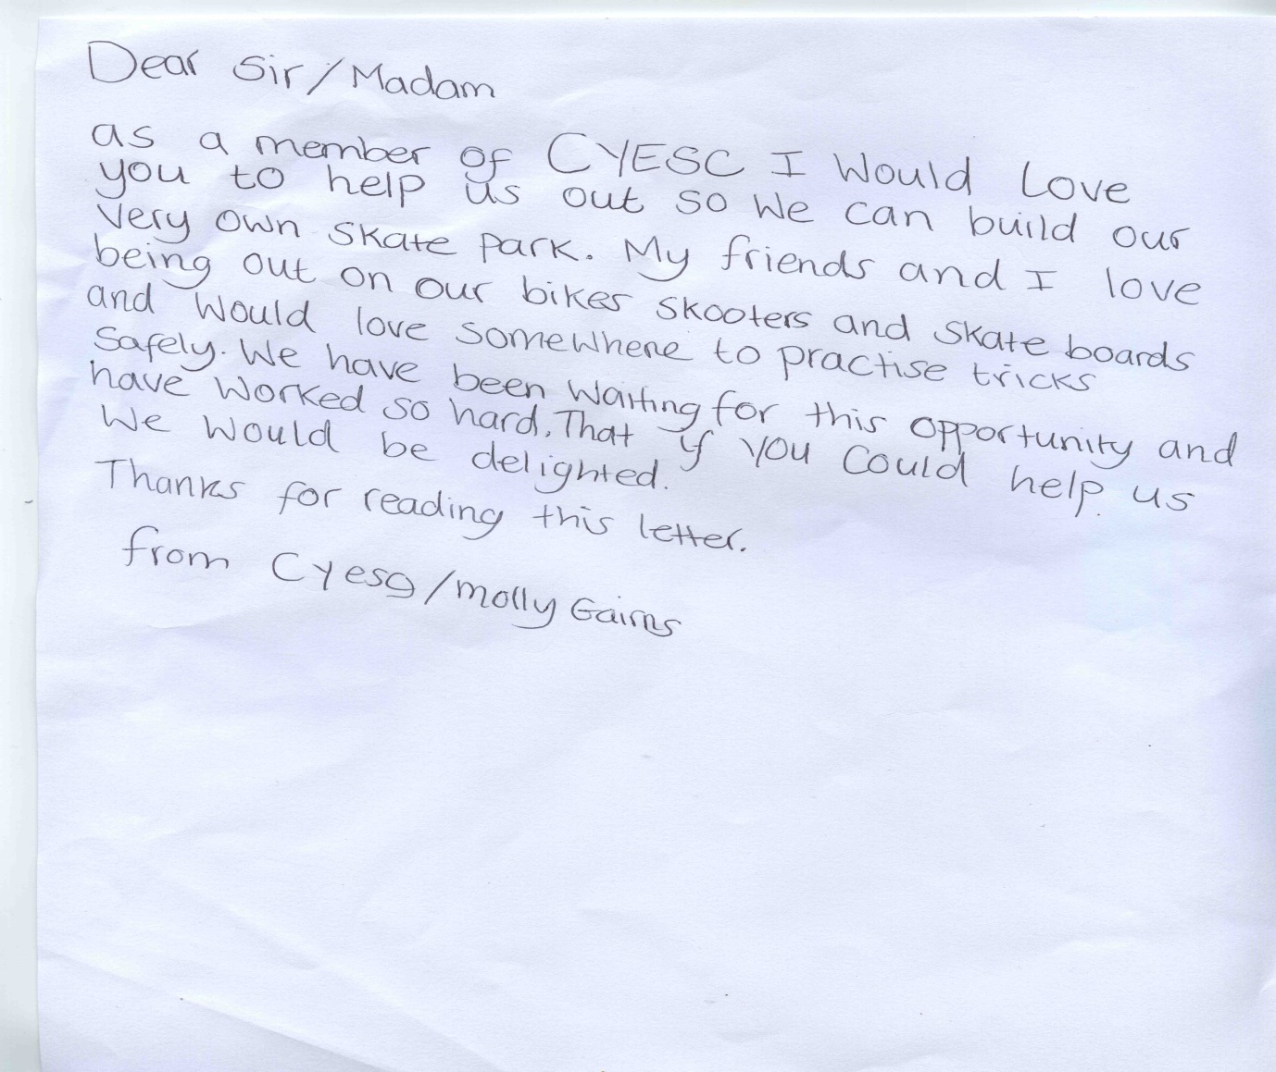
Molly Gairns taking part in the triathlon to raise funds for the bike and skate

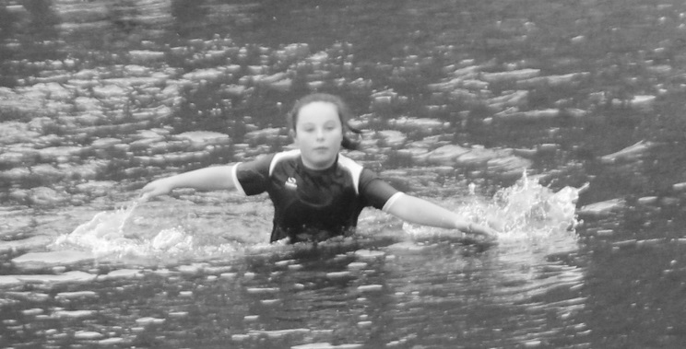
If you would like to support and are unable to ‘buy a block’ we are setting up a justgiving page. This will be live for 30 days from end of September.
www.crowdfunding.justgiving.com/Comrie-Skate-Park
Minimum justgiving donation is £2

