v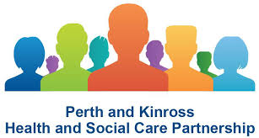
HEALTHY MINDS AND SUICIDE PREVENTION WEBINAR BASED WORKSHOPS
REGISTRATION FORM
To book a place on one of the free workshops please complete and return this form by email to: BIT@pkc.gov.uk
*Please be sure you can attend the full day and have access to a computer or smart device with the internet and sound for the webinars.
Your name
Contact email address

Please indicate which ONE of the following BEST describes your business area or interest in this webinar
Perth & Kinross HSCP
Perth & Kinross Council
NHS
3rd Sector commissioned service
Charity
Carer
Other (please briefly explain)

Please indicate your preferred date for the webinar (and a second choice if you wish)
Tuesday 19th May (9.30 – 12.30 and 13.30 – 16.30)
Wednesday 20th May (9.30 – 12.30 and 13.30 – 16.30)
Tuesday 26th May (9.30 – 12.30 and 13.30 – 16.30)
Wednesday 27th May (9.30 – 12.30 and 13.30 – 16.30)

Once a completed registration form is received, you will receive an email confirming the date that you have been allocated a space to attend the Webinar.
There is no pre-course work or reading prior to the Webinar.
The day before the event you will receive joining instructions to the Webinar by email.

Please return your completed registration form by email to: BIT@pkc.gov.uk

