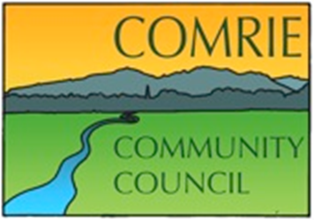

The ANNUAL GENERAL MEETING of the Comrie Community Council will be held via video conference (ZOOM) on Thursday

8th October 2020 at 7.00 pm

Agenda

Welcome

Minutes of the 2019 AGM

Chairman’s Report

Secretary’s Report

Treasurer’s Report

Nomination of Office Bearers

Date of the next meeting – 14th October 2021 at 7.00pm

