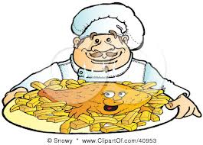

COMRIE HOTEL - TAKEAWAY MENU
Tel: 01764 670 239
From 5pm
Haddock and chips | £7.95
Chicken and chips | £6.50
Sausage and chips | £5.50
Haggis and chips | £5.50
Black pudding and chips | £5.50
Homemade steak pie and chips | £5.50
Homemade macaroni pie and chips | £5.00
Chips | £3.00

