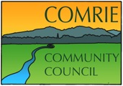
Minutes of the video meeting by Zoom - 7.00pm
14th May 2020

Attendance: David Robertson, Tim Lucas, Sheena Lucas, John Greer, Hannah Lucas (minute Secretary)
Cllr R Brock, Cllr S Donaldson, Cllr R McCall
Apologies: Gill Brock, James Preston

- Welcome
David opened the meeting at 7.00pm and thanked everyone for attending.

- Previous Minutes
- Matters arising from previous minutes – No matters arising.
- Minutes accepted by Sheena and seconded by Tim.

- Police Report
- There was no relevant information in the report regarding Comrie. Commanders Report is still being circulated to all Community Council members.

- Relevant planning applications
- Nothing to report

- Road Reports
- Nothing to report

- Treasurers Report
- There are still 7 accounts active.
- Money from the previous skate park fund has been deposited into the Admin account
- Various £25 deposits have been paid and £5k grant money has been received.

- Secretary’s Correspondence
Covid -19 Help Line
- Help Line moved remotely after 1 week of phone being manned at the church hall.
- Phone line is still open and receiving calls – Sheena is ensuring any calls are being answered. About 320 calls logged to date. This includes repeat callers and returned calls.
- Requests varied from – newspaper deliveries, mobile phone top ups, people just looking for general advice, excess food parcel deliveries and dog walking facilities.
- The post office has taken on delivery of newspapers to approximately 120 houses. Big thanks to them.
- Excess food boxes from PKC were donated/delivered to the Crieff Food Bank for reuse. Food bank appreciated the donations.
All 3 councillors wanted to convey their gratitude to Comrie Community Council for their speed in responding to the pandemic and ensuring that the community was well cared for. Special thanks to Sheena for taking the time to talk to everyone who phoned. Thanks to Tim and Davie for responding to these calls throughout the community and helping people with various issues or requests, Gill for getting the initial information leaflet out to everyone and to anyone else involved in making an excellent, well thought out response effort.
It was confirmed that the helpline would continue to run until it was considered to be non-essential. The number is unchanged and is 01764 679555.
The Community Council would like to extend a special thanks to all the local business who have made deliveries happen and ensured the community has been well looked after. They would also like to thank the First Responders who have delivered medication/prescriptions during these unprecedented times.
Shaky Bridge
- Now fully funded with £10,000 from Community Environment Challenge Fund (CECF)
- £6,000 from PKC Capital monies fund
- £13,000 from Gannochy Trust
- PKC will project manage the upgrade. Huge thanks to PKC, as it is a cost saving for CCC
- Works due to start late autumn and run into September/November
New access path to Shaky Bridge on west side from Monument Road
- The plan is to create an all abilities path from Monument Road along the route of the existing path and then down to the Shaky Bridge by upgrading the existing path. The new path from the road will incorporate a hard standing parking area for four cars and, further along, a sitting, viewing and picnic area with a bench seat and a large picnic table (incorporating integral seats) with a top extension to allow wheel chair use.
- The path work is fully funded with £12,058 from various funding sources. Thanks to Comrie Millennium Footpath Association for their help in brokering this for CCC
- £5,000 has also been donated from a private donor now living in Singapore but with links to Comrie and a further sum was donated to cover the cost of an all-weather seat with plaque to remember his parents
- A B Gairns Ltd has been commissioned to undertake the path work and to install the ground anchored memorial seat and picnic tables. This may take place at some stage during the summer.
- A second identical table is intended for the other (east) side of the bridge.
- Funding application has been submitted to an outside funding source for the two picnic tables and also for a small maintenance reserve to keep the path in good order. It will be some months before we know whether this application has been successful.
- Press Release – The Strathearn Herald will be given a press release within the next few weeks to announce the progress of the two projects and there will be further announcements when the work is about to commence and when it has been completed.

A special thanks to all involved with the funding applications and special thanks to Davie and Tim for all the hard work that was done behind the scenes.
Maclagan Cemetery
- Agreed that the CCC would put a seat in front of the gates and encourage people to go up and enjoy the view. Cemetery area, and access, was cleared of scrub late last year. The bracken around it is going to be treated to kill it and to open up the area further. A seat (engraved with Comrie Community Council 2020) was ordered and is now available for installation. Davie and Tim will install the seat this weekend.
- 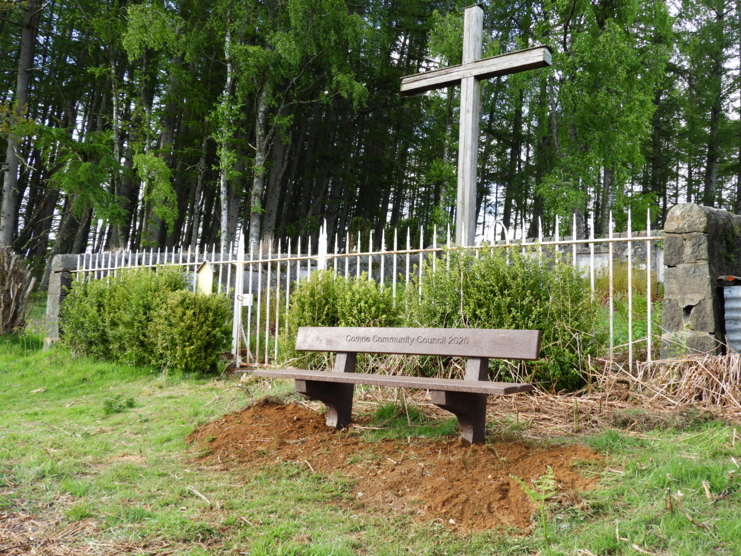
- Signs to direct interested people to the cemetery are being prepared by the Men’s Shed but the work is on hold at the moment. There will be two signs – one to be positioned on the A85 directing people up the Milton track and the other will be about ¾ mile up the track by the lay-bye directing people along and into the cemetery area.
Special thanks to Tim and Davie for organising all the above works and installing the bench.

Skateboard Park
- CCC has now taken over the management of the skate park and funds have been transferred to the admin account
- There were signs of damage on the skate park, Tim and Davie have repaired this and now there is no longer any danger for users.
- The grass has been cut around the skate park and looks good – thanks to Brian Henley
The damage caused by a vehicle to the grass in the Laggan Park in general earlier in the year has now all gone and the grass has recovered.
AOCB
- Holyrood Garden Party in July has understandably been cancelled but the guests who were invited this year will have their invitations carried over to next year. Holyrood has advised them directly to this effect.
- Sheena advised that the CCC Facebook page is progressing and she has populated the page with information. It will go live in due course.
- Davie wanted to extend his personal thanks to Tim and others for all their funding work on the Shaky Bridge project – Cllr Donaldson seconded this.
- Cllr McCall has not heard a great deal about the flood prevention scheme but did know there were 2 objections being filed. PKC are planning to talk to the 2 residents to try to resolve them quickly and avoid undue delay. There will be some delay due to these discussions though. She will update when more information is available.
- There has been a big increase in fly tipping throughout Peth and Kinross, Cllr’s are aware of it and any fly tipping should be reported. No news on the Crieff recycling centre opening – there needs to be a confirmation from the Scottish government and a Scotland wide approach to the re-openings. At present such visits are not deemed an essential journey.
- Toilets in Crieff and Comrie are still closed as they are not seen to be an essential service. They will remain closed until further notice. We must try to get the Comrie facilities open as soon as possible.
- Davie raised the issue of the old fish farm at Dunira. It is in a terrible mess. PKC are aware of this and are working with SEPA to try to clear the land.
- All the Cllr’s again wanted to thank the CCC and other community groups for their work and community spirit during the Covid lockdown. It has been noted throughout PKC how well co-ordinated everything was, especially the help line.

Meeting closed at 7.45pm.

Date of next meeting 11th June – probably via video conference again (Zoom) at 7.00pm. To be confirmed.

