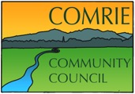

A meeting of the Comrie Community Council will be held by ZOOM video conference on Thursday

12th November 2020 at 7.00 pm

Agenda

Welcome
- Previous Minutes
  - Matters arising
  - Acceptance
- Police Report
- Relevant planning applications
- Road matters
  - Review
  - Actions required
- Treasurer’s Report
- Secretary’s relevant correspondence and updates
- Councilor’s Reports
- AOCB

Date of the next meeting – 10th December 2020.
By video conference at 7.00pm.

